Fall 2016

Healing and Transformation
By Carolyn Bagdoyan, RYT 200, LFYP

It is an amazing process to discover and witness how healing unfolds. We each have our own unique life experiences . . . one way or another they leave an imprint within us. The miracle of the body is that it takes in these experiences and finds a way to move forward--even as it retains imprints it has not found a way to release. Those imprints eventually add up--and leave their impression in the body as suffering in one form or another: tension, tightness, pain, mental fog, depression, anxiety, etc.

This summer I returned to Calgary, Canada to continue studies with master yoga therapist and teacher Susi Hately and began her rigorous, accredited yoga therapy certification program that has been my dream for the past 18 months.

Reflecting on my own path--from yoga practitioner, to yoga teacher, to sharing the therapeutic benefits of yoga-I have discovered that yoga can bring healing to the deepest layers of our being, relieve stress, and calm internal systems. That even in the Northern Virginia “go-go-go” lifestyle, yoga offers a path to reconnect with the self, find peace in the present moment, feel grounded, and settle the busy-busy monkey mind.

I’ve most wanted to truly help others with healing in a way that compassionately honors each person and empowers them with their own self-care.

People are more than their conditions. The gift of healing unfolds as we awaken to the imprints we have retained in our bodies. I love being part of this healing process by helping you deepen internal awareness of your body’s needs and respond to your body’s callings. How the body moves and breathes can reveal where imprints have been retained; together we discover paths to releasing what no longer serves, so that you can steer your own healing transformation--whether it be toward relief from chronic pain, new heights and ease in physical well-being, or greater calm and clarity of mind.

My role is to support you in your own sustainable growth and healing as a transformative life practice. Most of my clients have little or no yoga experience--they merely seek more relief, ease, and joy in their lives. Let me know if I can help support your own journey.

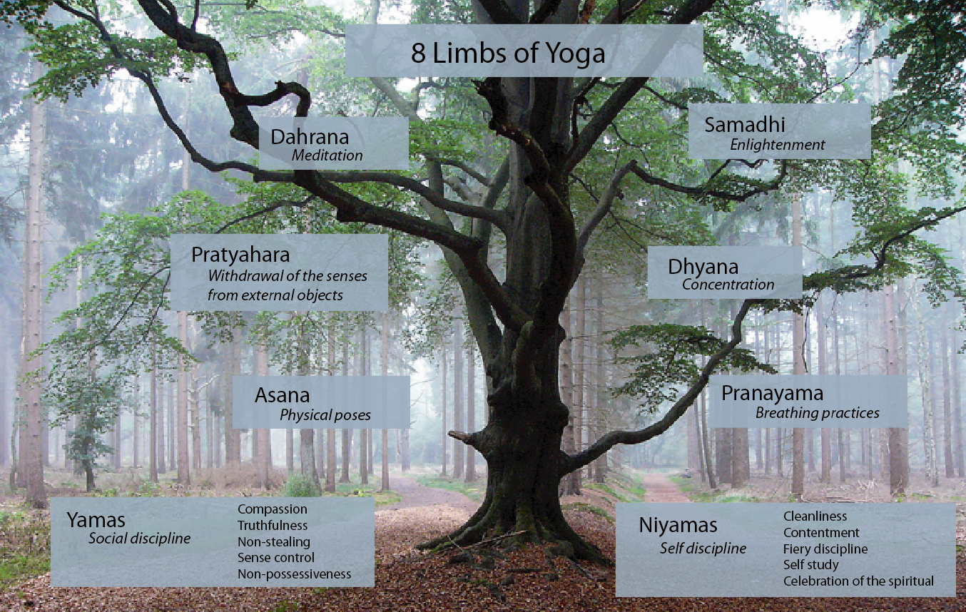
Photo source: deannehampton.com

For more information, contact me through my website at www.hearttreeyoga.com or via email at hearttreeyoga@gmail.com.

