Spring 2017
By Carolyn Bagdoyan, RYT 200, LFYP

Happy Spring! It’s the time of year when we’re ready to shake off any lingering stagnation from winter and spring forth into new growth. How can we grow optimally?

Last month I was privileged to join two colleagues in a presentation about cultivating organizational well-being –essentially how to increase overall workplace wellbeing and performance by utilizing mindfulness, body awareness and self-care practices, as well as “listening for understanding” communication techniques. Together these foster better clarity around unmet workplace needs and better serve individuals and teams moving forward.

It begs the question though – how often do we listen for understanding to what our body has to say about its own state of wellbeing? Do you speak and understand the language of your own body? How can you increase awareness around your body-mind connection and be prepared to respond to what your body is telling you? What does that even mean?

If you are up for an experiment, try this: Over the next week, pick 3 situational things that you know create some sort of unease for yourself. I’ll name some possibilities here just to get you started. For example, being stuck in traffic; forgetting something you needed; having a difficult exchange with another person; reading a news item that displeases you; or worrying about another person, your job, or your family. Pick something that tends to come up a couple times during your typical week. And, whenever the situation arises in the next week, notice where in your body you store physical tension, tightness, strain or unease in response to that situation. Notice the thoughts and mental discourse in your mind and the physical response in your body. (Know that I’m not asking you to change anything right now. For now, just notice.)

What happens? Do your shoulders or neck get tight? Does your stomach become queasy? Does your breath get shallow? Does tension arise in your low back? Do you experience gripping through your chest? It could be anywhere. What specifically happens in your body?

At week’s end, compare these 3 typical responses. Do they differ depending upon the situation? For example, does the traffic response differ from the disagreeable reading response?

Working in yoga therapeutics, I’ve seen clients draw parallels, see patterns, and gain insight into chronic pain and tension –and we work with breath, movement and stillness to unravel old dysfunctional patterns and create new neuromuscular ones that serve the body better. It is an empowering experience to understand your body’s communication patterning and to be able to respond appropriately!

This spring, may you embark on your own journey of gaining awareness around the language nuances of your own body so you can respond to its unmet needs. May you learn to serve your body better so it can serve you better!

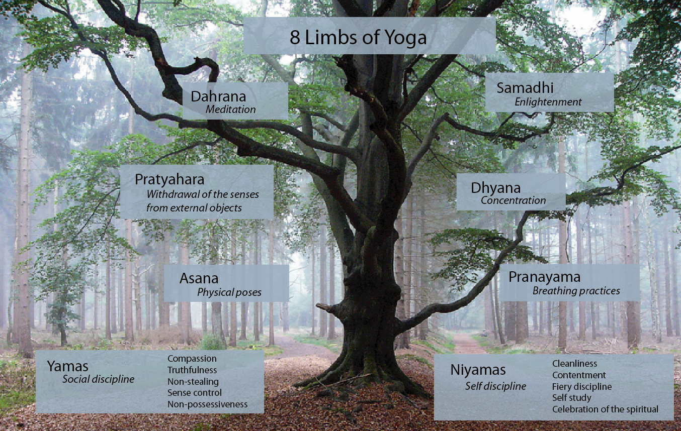
Photo source: deannehampton.com

Carolyn is a RYT 200 yoga instructor and is pursuing her 1000-hour IAYT Yoga Therapist Certification with internationally recognized yoga teacher and therapist Susi Hately of Functional Synergy. Carolyn is also a Level 1 LifeForce YogaⓇ Practitioner, trained in its yoga protocol for balancing mood and mood management. For more information see www.hearttreeyoga.com or contact Carolyn via email at hearttreeyoga@gmail.com.

