Summer 2017
By Carolyn Bagdoyan, RYT 200, LFYP

Reset

This summer newsletter is really coming in the thick of summer, rather than its infancy. Today is July 4th. The last month was a whirlwind of returning from my yoga therapy studies in Canada, closing out the school year and my career as a preschool teacher, celebrating my oldest son’s graduation, flying to California to take a 4-day Yoga Nidra certification course, joining family and my 2 boys to spread my late mother’s ashes, and taking in So. California attractions with my Dad and brother. In short, a whirlwind of sacred time of connecting, learning, and loving.

During my Yoga Nidra training in CA I was thinking about how our bodies are in a constant state of response, of action, of doing. It is almost like the body has forgotten how to be in a state of relaxed being and of feeling. Yet that state of being and feeling is really the RESET for our body-mind. It is what restores and heals.

The Yoga Nidra certification course I took teaches how to reset the body mind and enter into a state of conscious relaxation. Yoga Nidra is an ancient yoga practice where the practitioner essentially enters into middle state of consciousness (in science speak – in the brain state of theta and alpha waves,) a place between our ‘normal’ actively awake and deep sleep states. In this middle state of relaxed consciousness, practitioners can become more in tune with what the body/mind really needs--by recognizing and releasing areas of holding, control or tension, and consciously creating and manifesting inner healing. Yes . . .finally giving the body mind a calm space to witness, explore and dissolve physical sensations, thoughts and feelings that no longer serve. This place can be more effective than sleep in helping the body to restore; and regular practice has been linked to reducing stress and improving well-being as a complementary therapy tool for a variety of diseases and conditions.

I can say that the opportunity to spend 4 days teaching and receiving Yoga Nidra practice felt delicious. It was also incredibly inspiring to learn how these practices have been shown to aid in healing and can be used to empower others for greater wellbeing. In other words, I’m hooked.

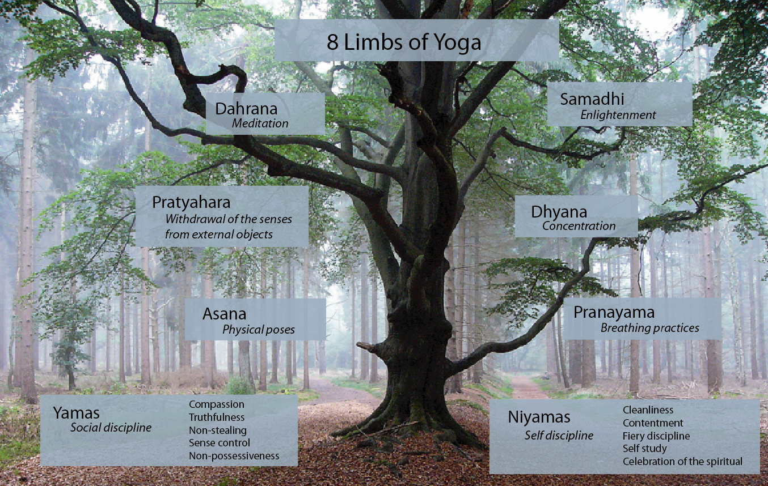
Photo source: deannehampton.com

Carolyn is a RYT 200 yoga instructor and is pursuing her 1000-hour IAYT Yoga Therapist Certification with internationally recognized yoga teacher and therapist Susi Hately of Functional Synergy. Carolyn is also a Level 1 LifeForce YogaⓇ Practitioner, trained in its yoga protocol for balancing mood and mood management, as well as a certified Yoga Nidra instructor. Carolyn empowers individuals of all ages and activity levels to progress towards greater health and wellbeing using therapeutic yoga practices. For more information see www.hearttreeyoga.com or contact Carolyn via email at hearttreeyoga@gmail.com.

