Winter 2016

Reflect and Renew
By Carolyn Bagdoyan, RYT 200, LFYP

It is that time of year. The chill of winter sets in and as the bustle of the holidays draws to a close, we find ourselves in reflection. How have we supported ourselves this past year? Where are we headed? How can we bring renewal into our lives for a New Year filled with a greater sense of health and wellbeing? Can 2017 be a year of personal growth, promise and discovery?

Transformation happens with awareness. If we aren’t aware of how our body responds to movement and stressors, it is difficult to make changes, or to integrate benefits to their fullest extent. How often do we set a New Year’s goal for better health and improved fitness but find that it isn’t working out for us a few weeks or months into the year?

Increasing our ability to feel our movement and understand how to move well, to feel the body’s bracing and tension holding patterns, and to recognize how the body responds to stressors are tools that enhance our ability make informed choices for implementing self-care – whether that self-care draws from yoga asana (pose) practice, breath or meditative techniques or restorative stillness. You can learn to make the most of these practices when you understand your body’s whisperings. You can learn to hear, read, and honor your body’s signals and grow in way that serves you, alleviating tension and strain in the process. Transformation becomes available because you are more present with your own state of being.

I’d love to be part of your journey of renewal and transformation in 2017.

And here is this: I’m really delighted to share some news for the coming year! While Heart Tree Yoga remains a mobile service in which I can come to your home – I also now have a lovely healing space within my home to offer private sessions to clients as an alternative option.

Also, this January 2017 I’m returning to Calgary, Canada for more study with master yoga therapist and teacher Susi Hately as part of my yoga therapy certification program. I’m looking forward to coming home and sharing more pathways to greater healing and wellbeing with you!

Let me know how I can support your own journey of renewal as you launch 2017 and seek more ease and wellbeing in your own life.

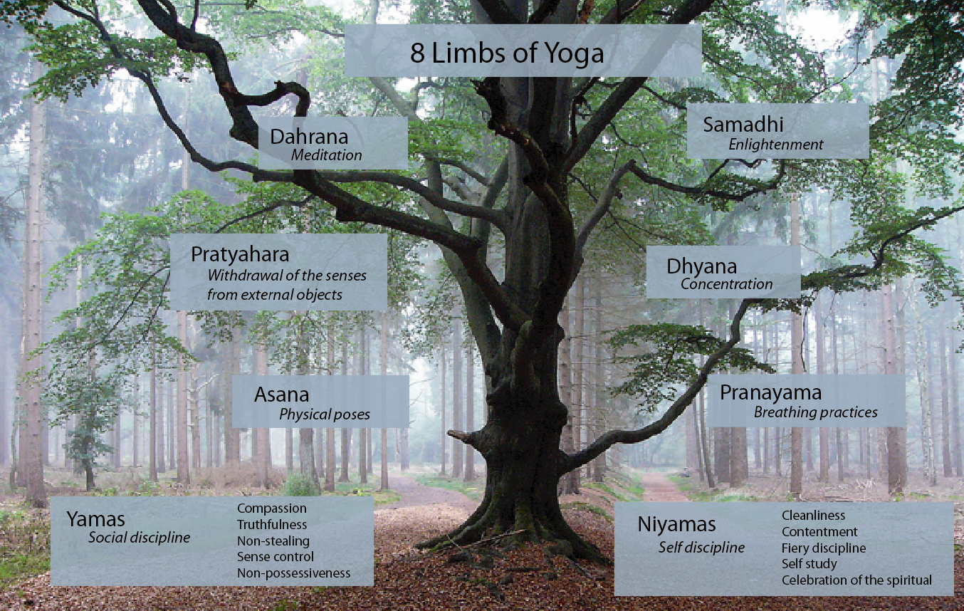
Photo source: deannehampton.com

For more information, contact me through my website at www.hearttreeyoga.com or via email at hearttreeyoga@gmail.com

